How to Use Your SupertutorTV Course

Welcome to SupertutorTV! This comprehensive guide will help you learn about all the content and features you will find in this online course to make sure you get the most out of the course.

Before getting started, we wanted to give you a heads up on some helpful resources that will enhance your SuptertutorTV experience.

First, we give you access to official SAT practice exams and answer explanations. We also provide a 1 month, 2 month, 3 month, and 6 month pacing guide for preparing for the ACT/SAT. These guides are designed to help you develop a studying plan depending on how far out your test date is.

We also have a spreadsheet to help you stay up-to-date on all the videos we’ve released. You can use this spreadsheet as your own personal tracker to check off what videos you have and haven’t covered, as well as checking how long every video will take to watch. Additionally, this spreadsheet also shows whether or not a lesson and problem set packet has been uploaded for each video.

You can find all of this at http://supertutortv.com/actcourseresources for ACT resources, and at http://supertutortv.com/satcourseresources for SAT resources.

Now, on to the course!

The first thing you will need to do, of course, is sign in. Using your registered email address and password, you will be able to access the course.

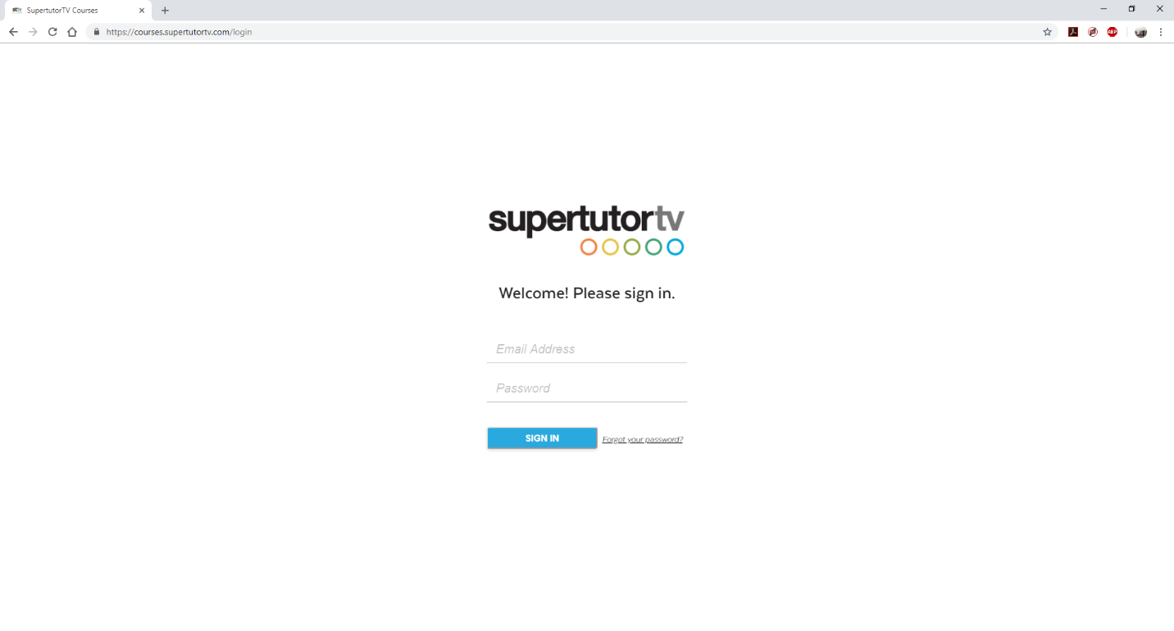

After singing in, you will be redirected to your SupertutorTV Dashboard. Depending on which course you paid for, you will either see “The Best SAT Course Ever,” “The Best ACT Course Ever,” or both.

In the top right corner of your course, there is a submenu that allows you to take a variety of actions: return to your dashboard, rate or review our course, leave feedback, refresh the course, ask for help, and log out.

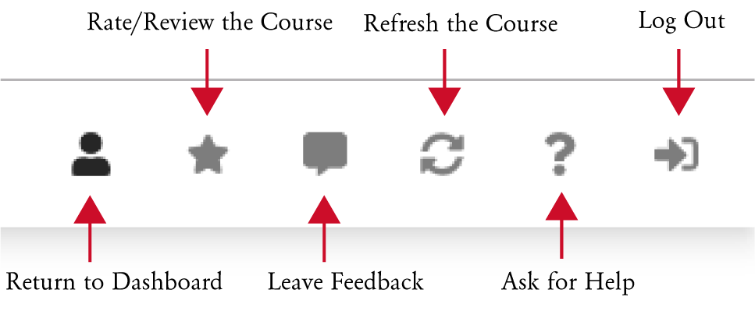

Refreshing the course will help ensure that you are receiving the most up-to-date content. If you experience difficulty using your course, press this button to see if it will resolve the problem. If not, you can always “Ask for Help,” which will redirect you to our FAQ and Announcement page, where you can find helpful answers, as well as the option to submit your own request.

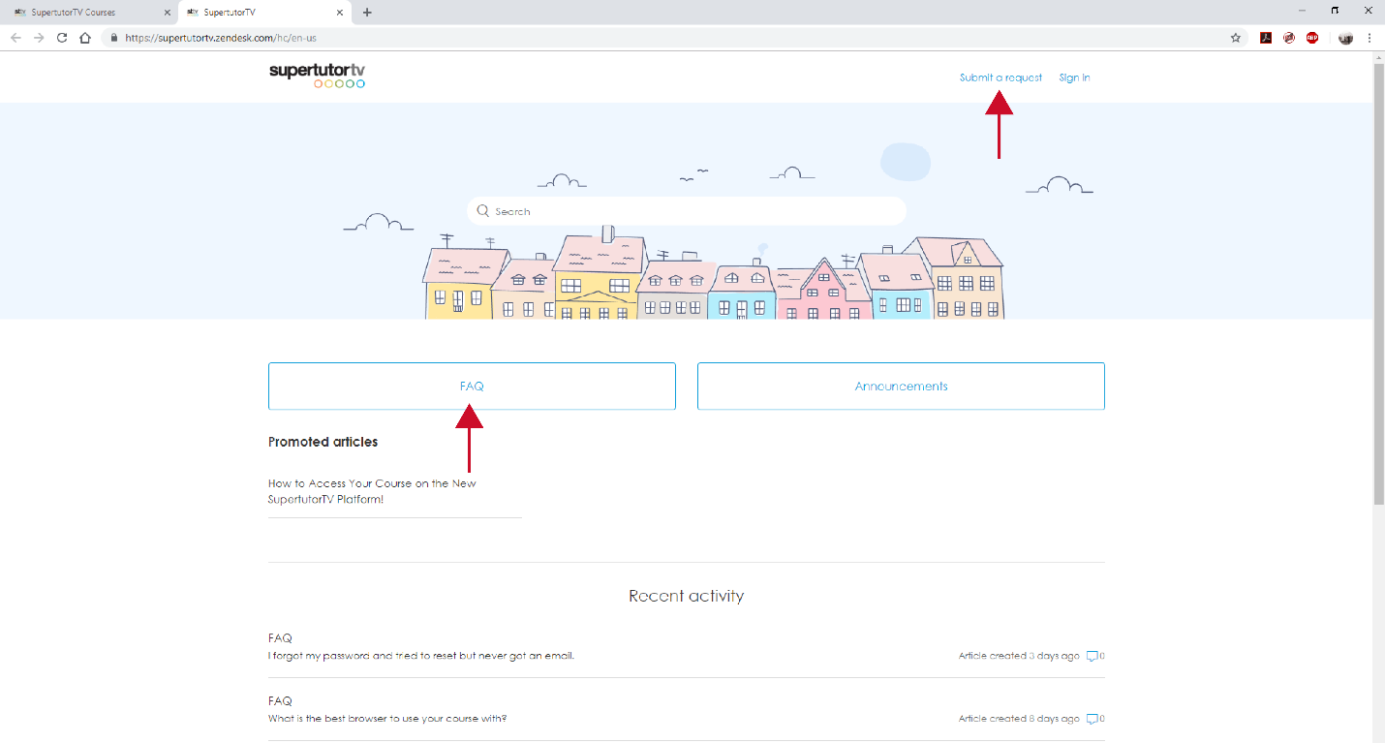

Once you select either the SAT or ACT course, you will be taken into that course. The course homepage is laid out as so:

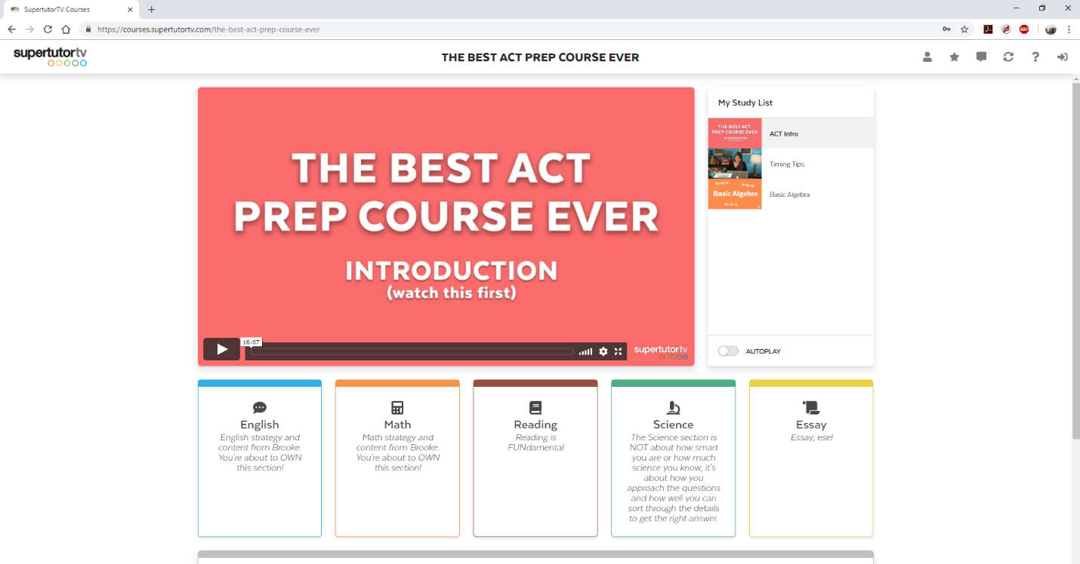

In the center of the screen is the introductory video which, like this guide, is meant to help you navigate the course, as well as explain how the course will help you prepare for the SAT and/or ACT.

To the right of the center video is “My Study List,” a playlist of videos filled with strategy and content depending on what videos you add to it (more on how to add videos later).

As you can see, the ACT Prep Course the subjects are English, math, reading, science, and the essay portion.

For the SAT Prep course, the subjects are writing and language, math, reading, and the essay portion.

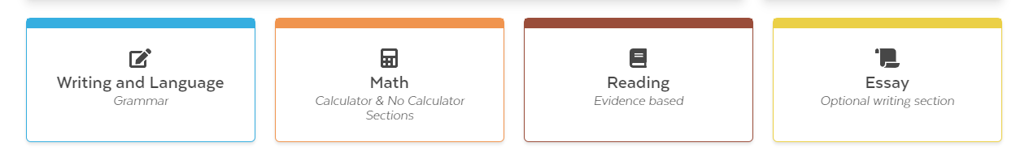

What happens when you click on and enter one of these subjects? Let’s find out what happens when you select the math section.

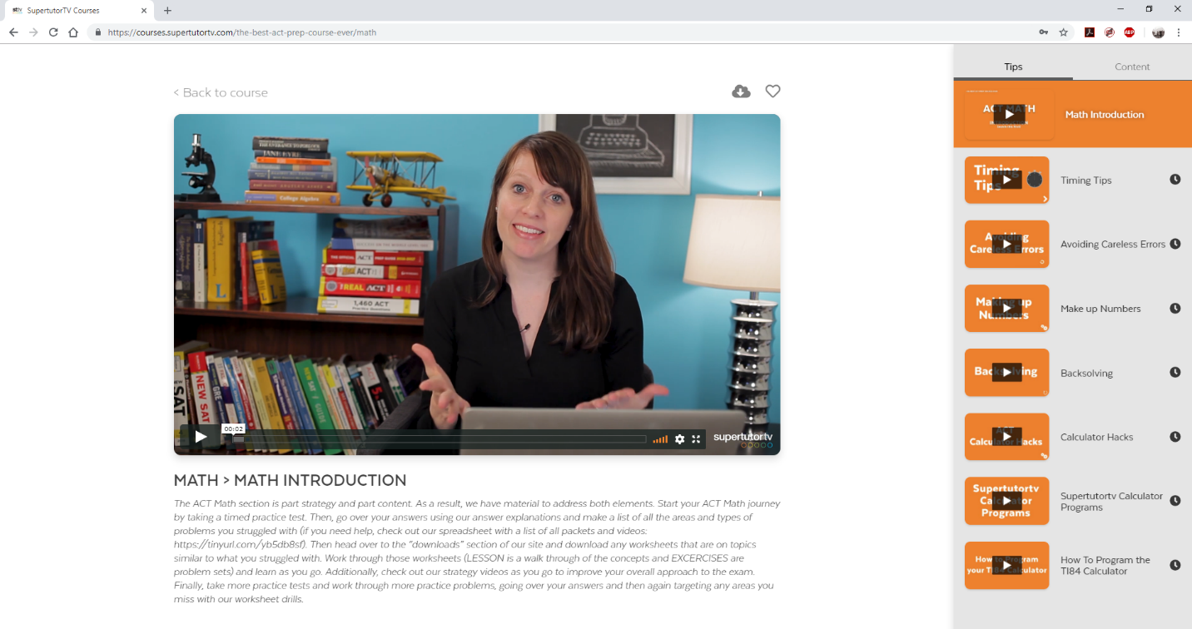

We are brought to the math page, and the first video that immediately starts playing is the “Math Introduction” video, which will help prepare you for what to expect from this portion of the ACT.

Once again, you can find the video playlist for this section in the right-hand column.

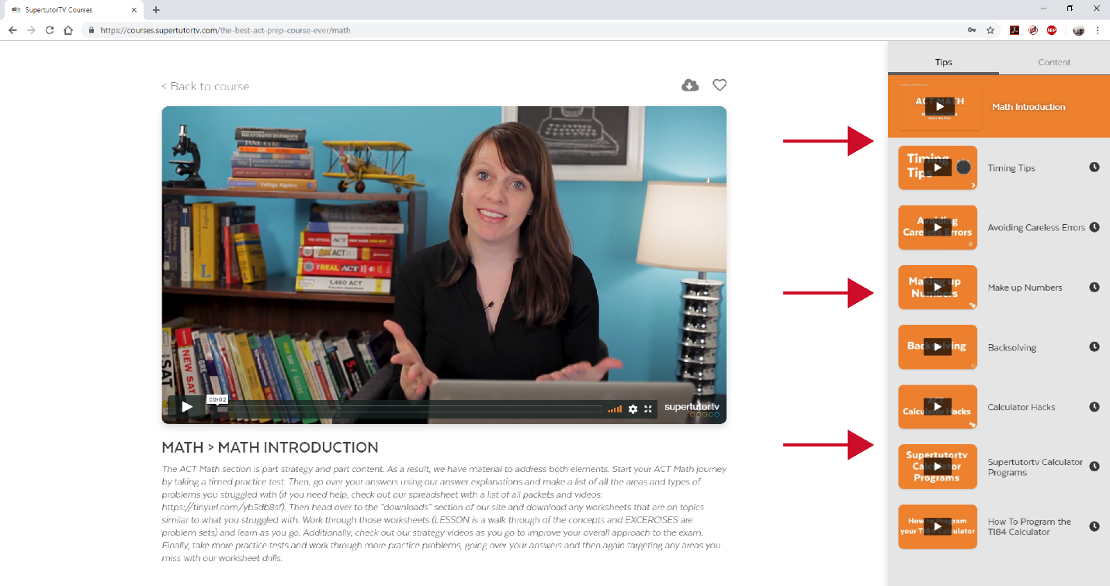

You may have noticed that once we entered the math section of the course, there were two headings for the video playlist: “Tips” and “Content.” This is how the video playlists for every subject are laid out, for both the SAT and ACT Courses.

“Tip” videos offer strategic advice on how to best approach the exam and its individual sections, like how to deal with timing or access our useful calculator programs.

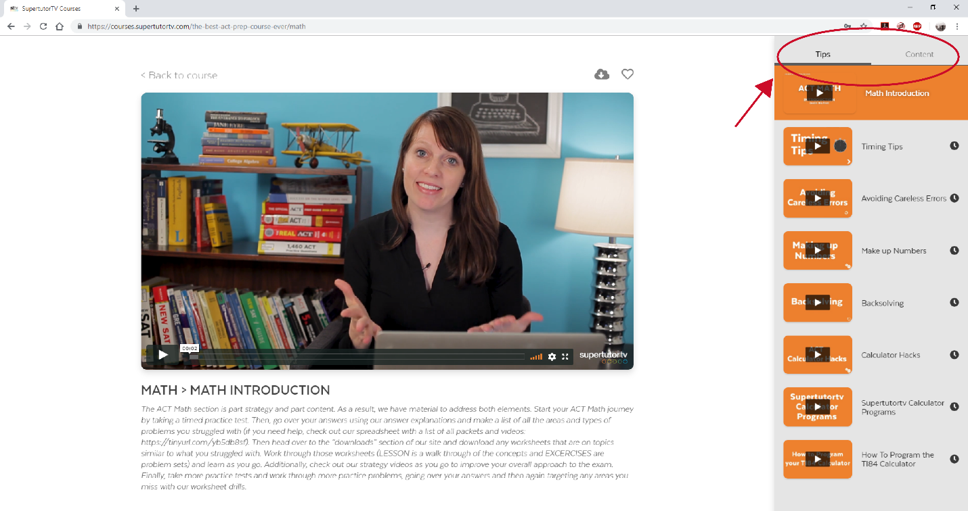

English (ACT), writing and language (SAT), and math sections all contain the most content, as there are different rules and topics you need to know before taking the exam.

There’s not as much content for reading and science (ACT), as most of the questions in these sections don’t require outside knowledge and are best prepared for by drilling and completing practice tests.

When you click on “Content,” you will be able to view a new set of videos. Content videos are designed to help you master the outside information you need in order to do well on your exam.

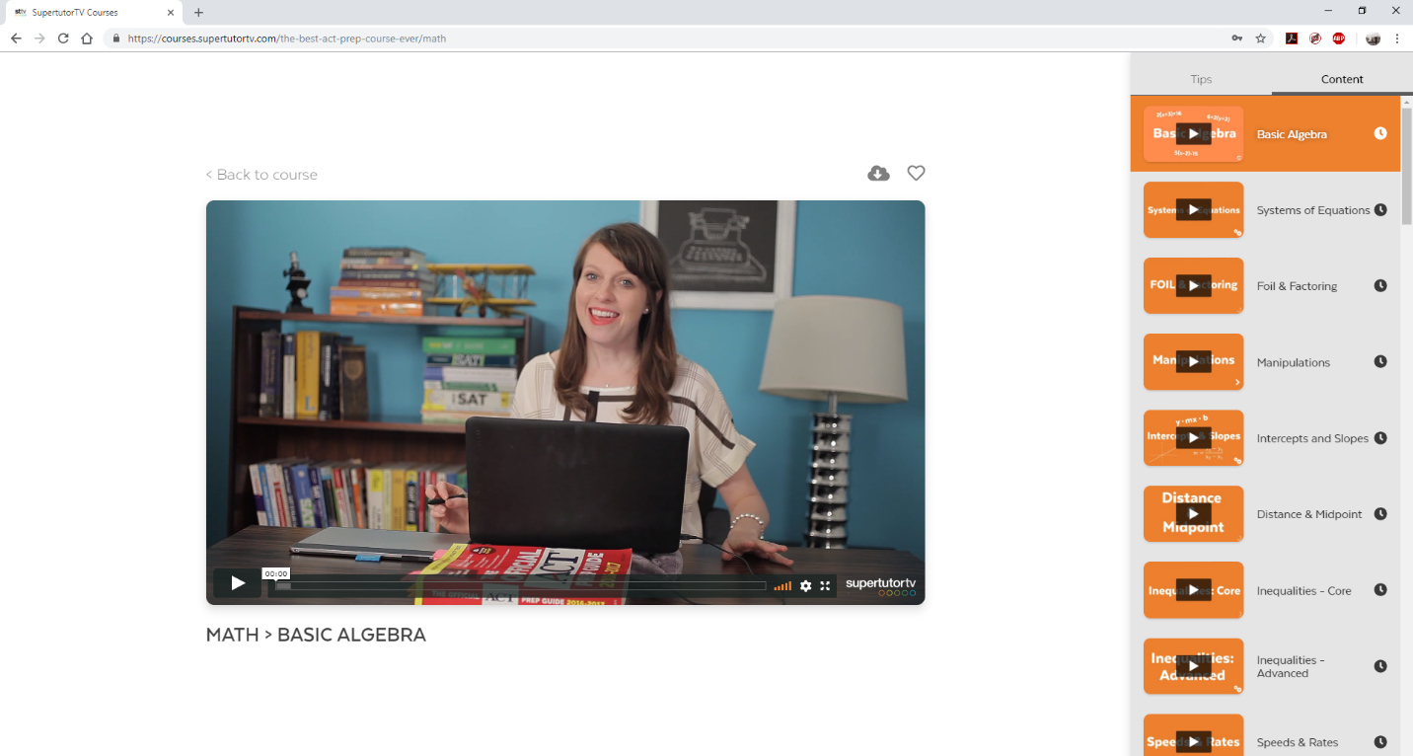

The clock symbol next to the video title means that you have already watched the video lesson. This will help you keep track of what lessons you have already covered. However, the clock will pop-up whether you’ve watched 30 seconds or the whole video, so use your video spreadsheet to self-monitor your viewing history.

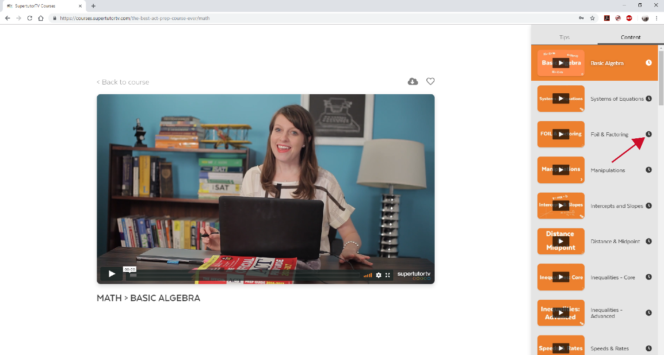

Content videos break down specific question types and topics. You can find downloadable PDF’s for lessons and problem sets by clicking the cloud button above the video. This button will give you access to all of the PDF’s.

Note: for the ACT, there are no downloadable PDF’s for the Reading and Science sections. For the ACT essay section, we provide 5 downloadable essay prompts, and for the SAT essay section, we provide examples of essays that received perfect scores.

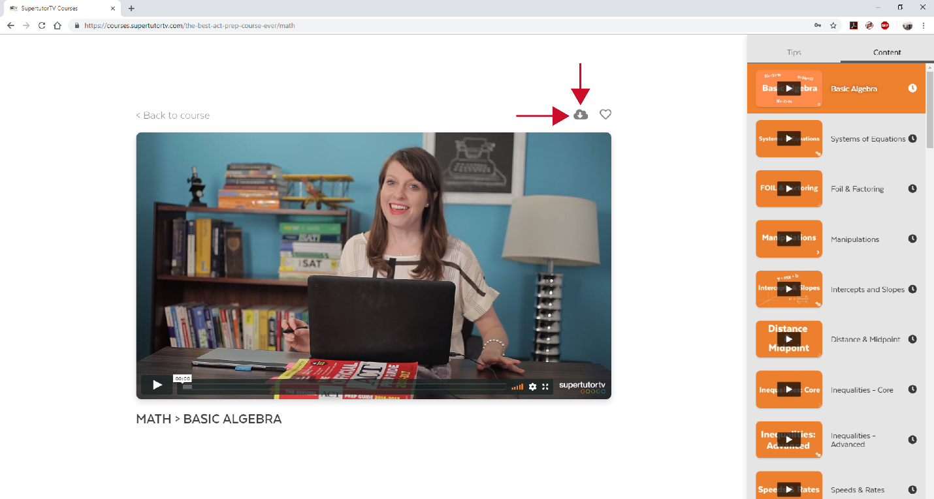

Once you click on the cloud, a window will pop up containing the PDF’s.

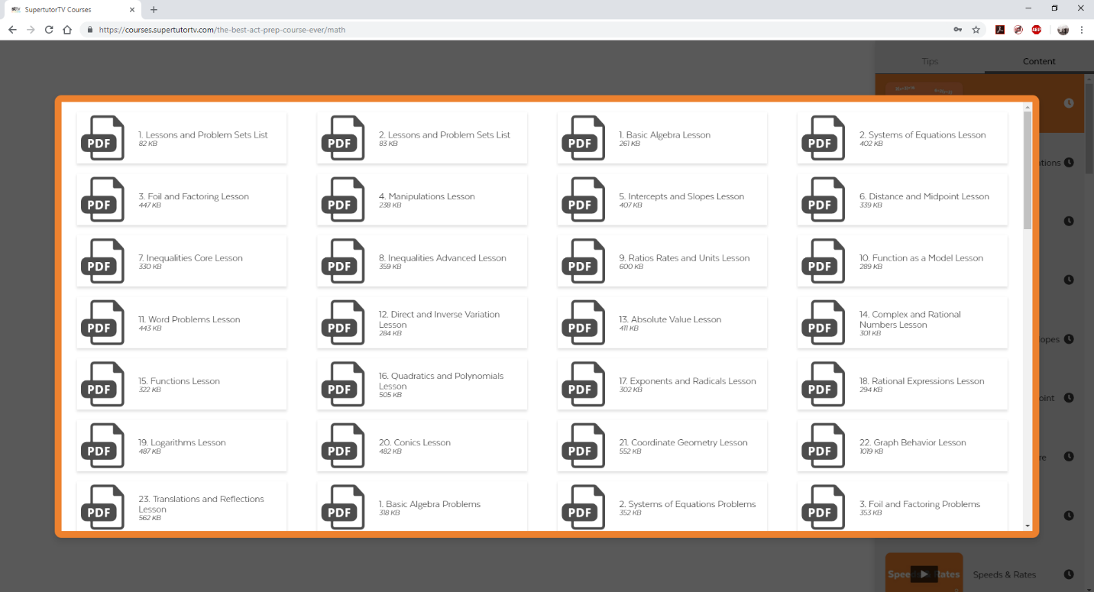

Just click the PDF you want to download and save it to your computer. Keep in mind there are two files for each math topic: a lesson and a problem set. Each file is named appropriately.

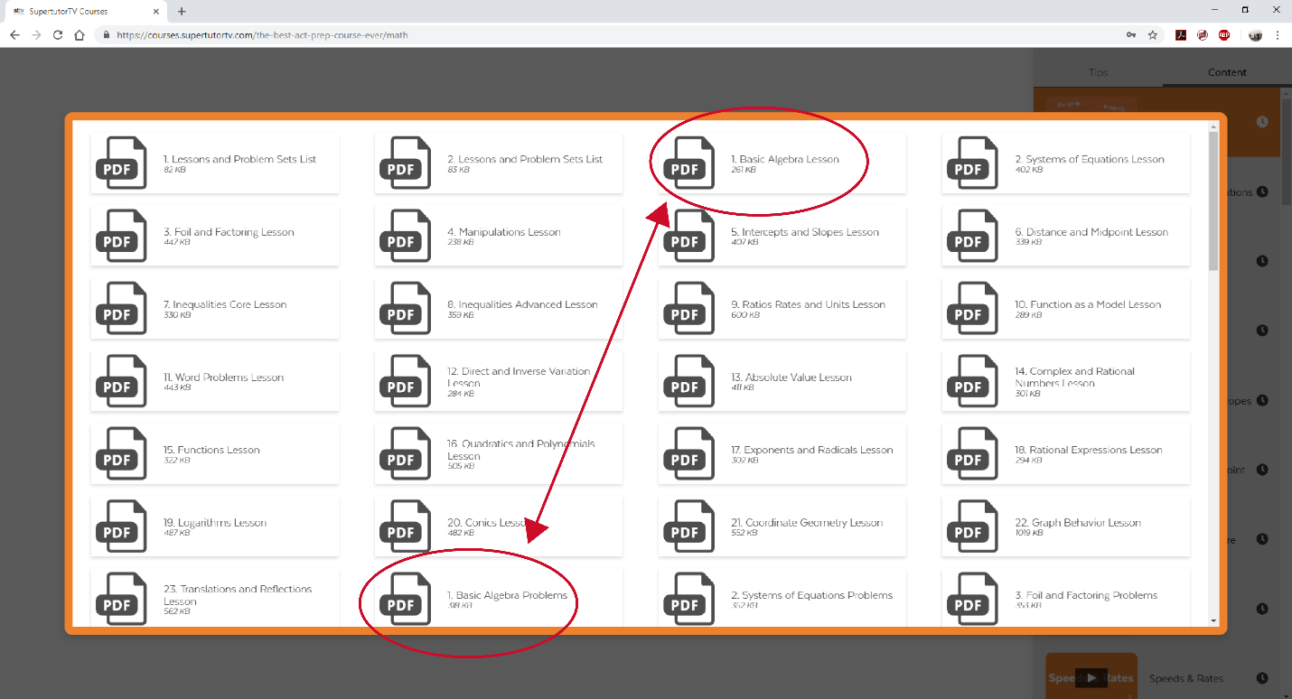

As you can see, there are two files titled “Basic Algebra,” but one is called “Lesson,” and the other is called “Problems.” Once you get through the lesson and the video for a certain topic, we recommend going into the problems PDF to gain some hands-on practice. Just click the file you want to download it!

Much like the clock symbol in the video playlist, a green checkmark will appear next to files you have downloaded. This checkmark will only appear once you exit and re-enter the downloadable PDF window.
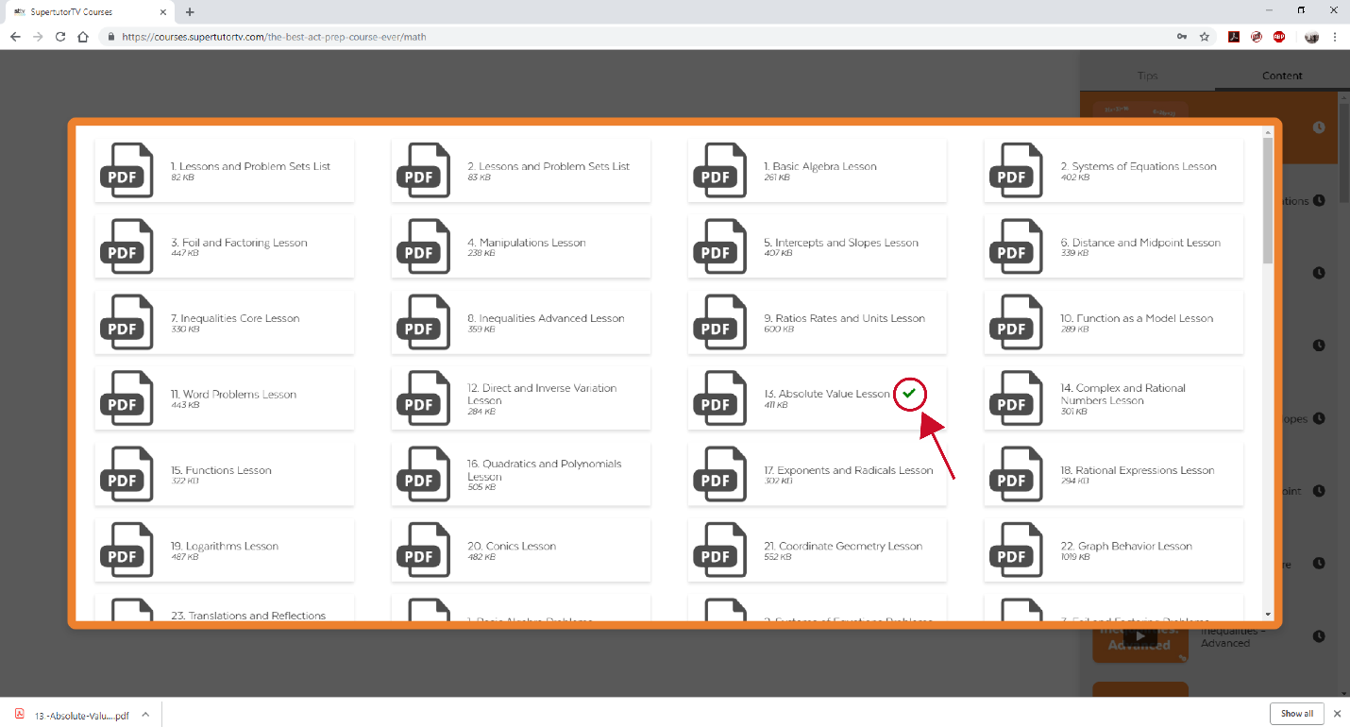

Next to the cloud is a heart button, which will allow you to add videos to your study list. Maybe it’s a video you know you’ll want to re-watch in order to master the material, or maybe you don’t have time to finish the video and you need to save it for later. Adding the video to you study list will help you add it to you own personalized playlist, which is viewable on login.

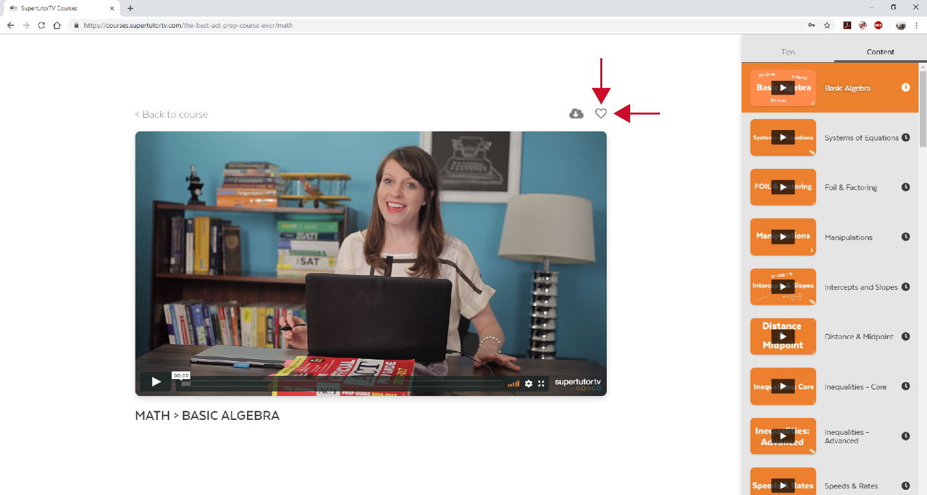

Check the homepage to see your updated study list. To head back to the homepage, you can hit “Back to Course” on the upper left-hand side of the video. (You can also see that the heart symbol is now red, indicating that the video has been added to your study list).

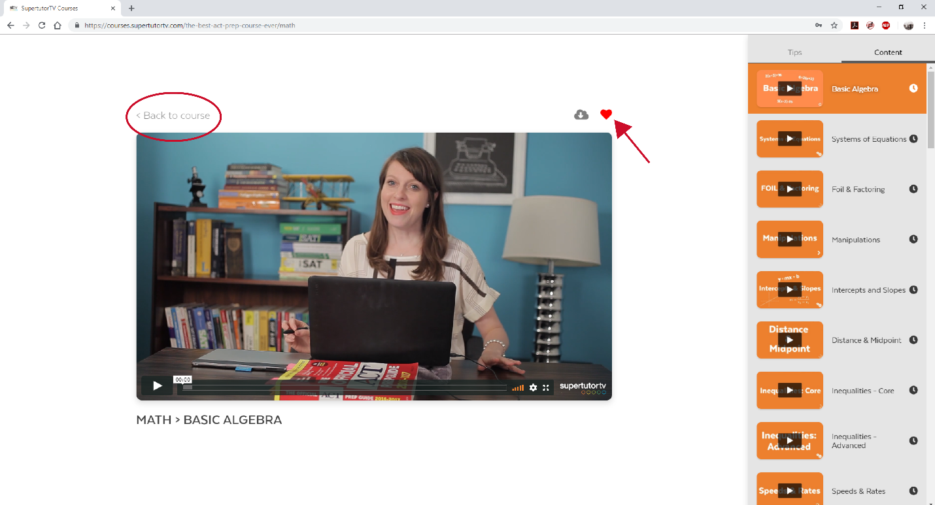

Here, you will see the video you “hearted” is now added to your study list. With this function, you can create a customized playlist of topics you want to study from a range of subjects.

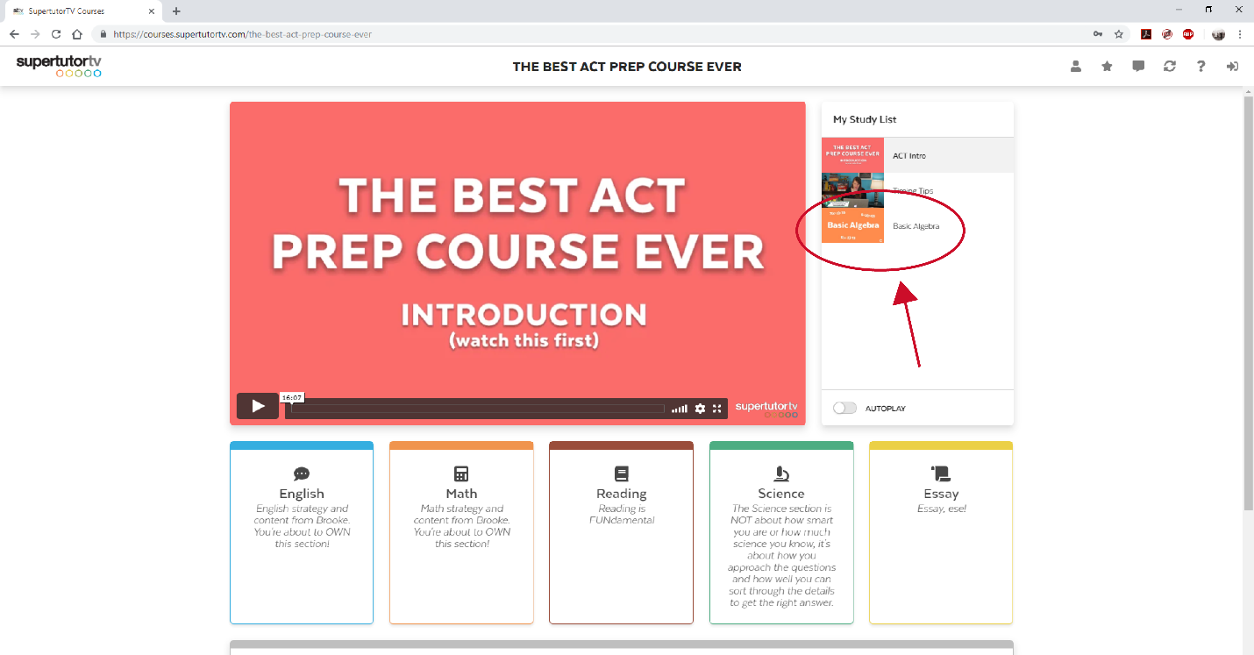

You can also remove videos from your study list whenever you want. Hover your mouse over the video until the “X” appears. Click the “X” to remove the video.

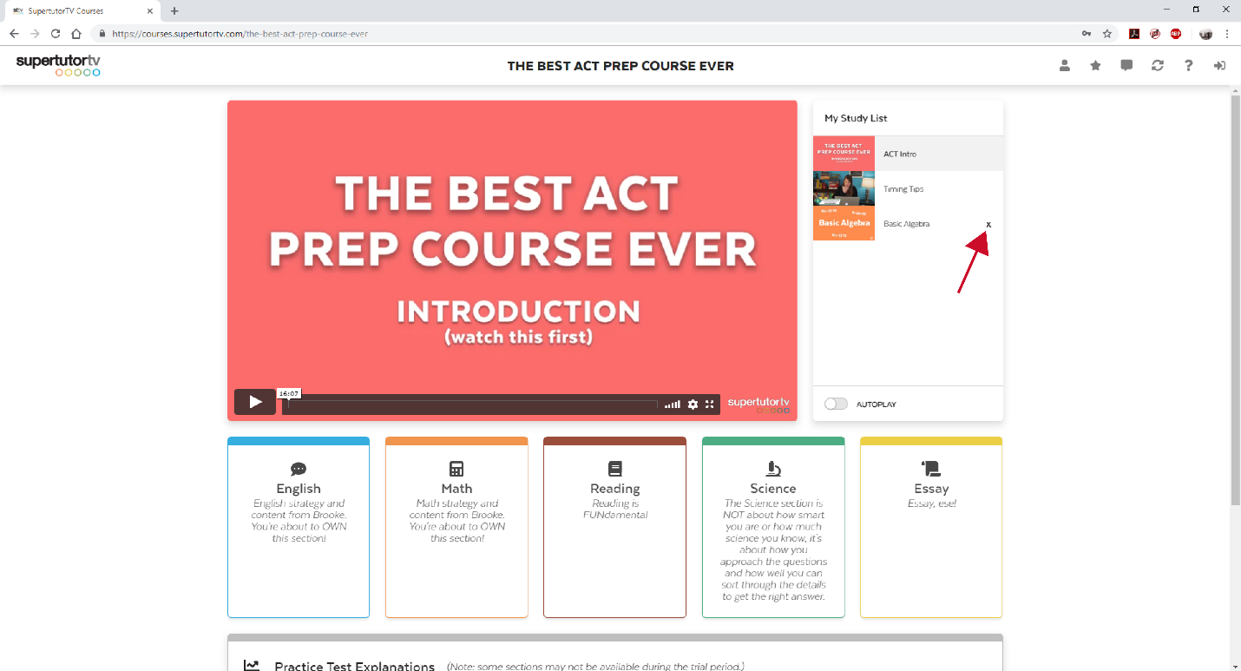

Now that you’re back on the course homepage, you can scroll down to find practice test explanations.

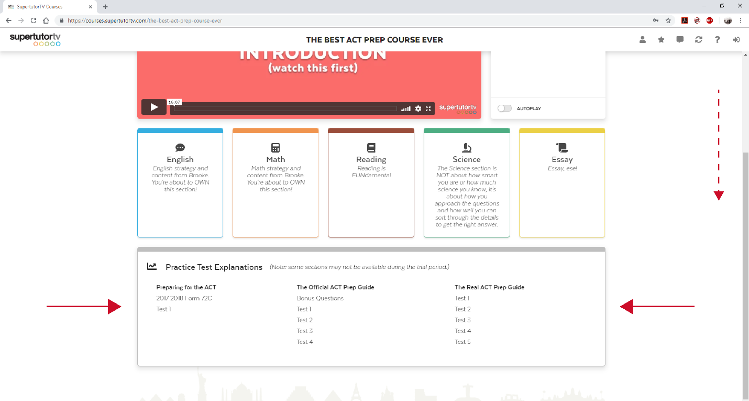

Click on a practice test to view video explanations for the exam’s answers. (Note: some sections may not be available during the trial period.)

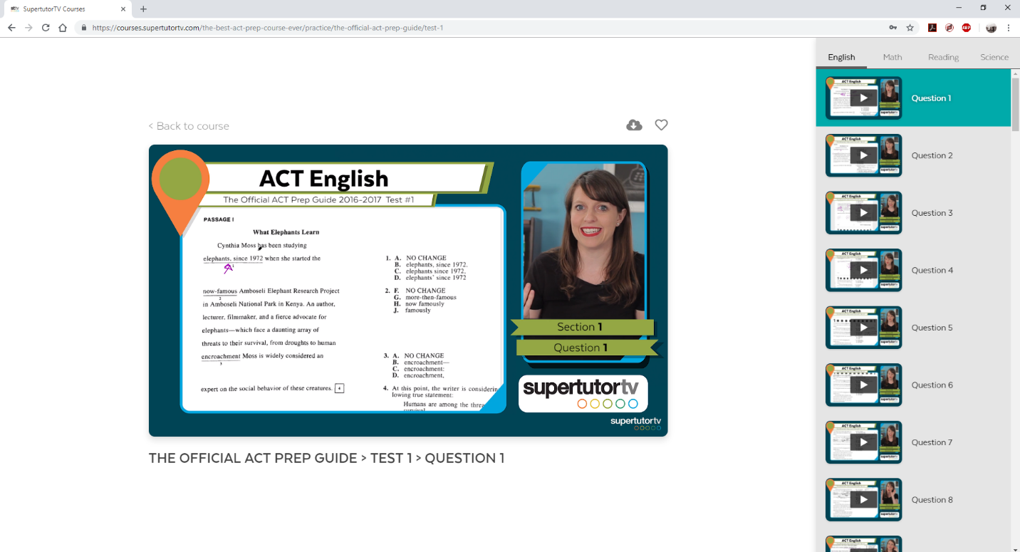

Here, the video playlist contains explanations for each question on the practice tests. You can also see that the playlist is divided into the different sections of the exam.

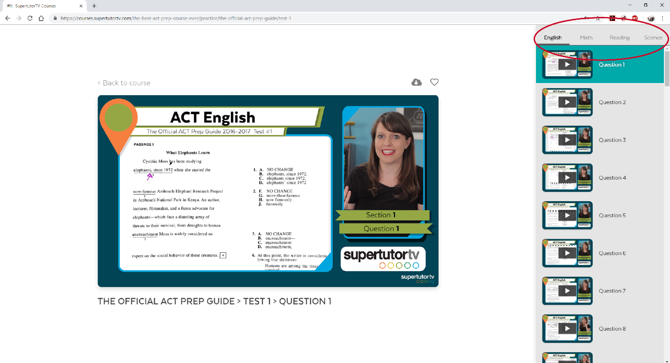

By clicking on each section heading, you can move between the video playlists for each exam section.

On the practice exam pages, if you click on the cloud button to view downloadable PDF’s, you will find study material, like our cram plans and ACT cheat sheet:

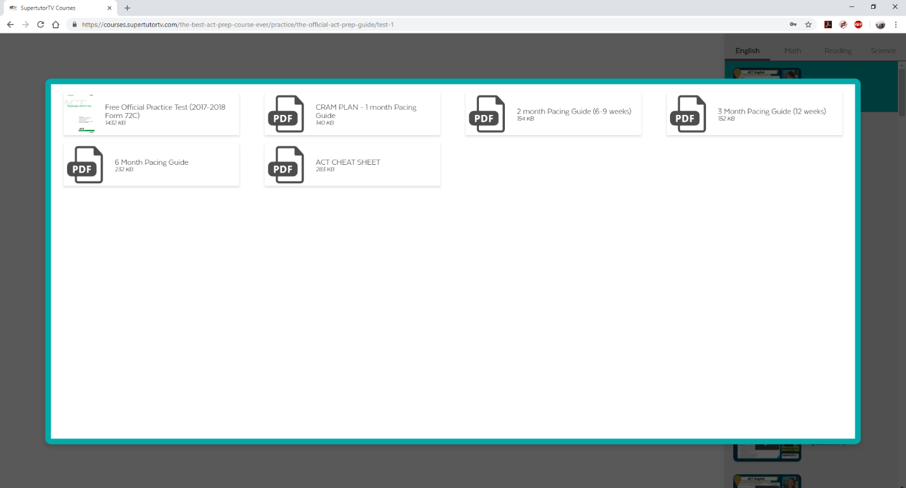

Those are all of the features included with your online course. We are continuously making improvements, so you will be sure to see more awesome content added in the future.

Need Assistance?

If you have questions or need technical support for The Best SAT Course Ever or The Best ACT Course Ever, please submit a request through our help desk: supertutortv.zendesk.com. You can also email us at info@supertutortv.com. Also, please feel free to contact us if you ever come across a typo or an answer explanation that doesn’t make sense. We are more than happy to answer any questions you have regarding the course.

You can also call our office at 424-253-5036, though we communicate more reliably via email. Some of our tech support team works remotely, so your questions are likely answered fastest when submitted through our online portal or via email.

